TESTA CHALLENGE APPLICATION FORM
Apply before October 25th

Welcome with your application!
We are here to help you with your application and are happy to give you feedback on your proposal. To ensure feedback, make sure to send in your application no later than October 12th, 2022, at 22:00 CET.
Submit your final application to malin.wiederholm@stuns.se. The deadline for the project proposal is October 25th, 2022, at 22:00 CET.
If your project is selected for the Testa Challenge 2023, you will be contacted between the 5th–9th of December 2022.

Questions? Do not hesitate to contact us!
We are more than happy to answer all your questions, please contact malin.wiederholm@stuns.se.
Testa Challenge is made possible thanks to
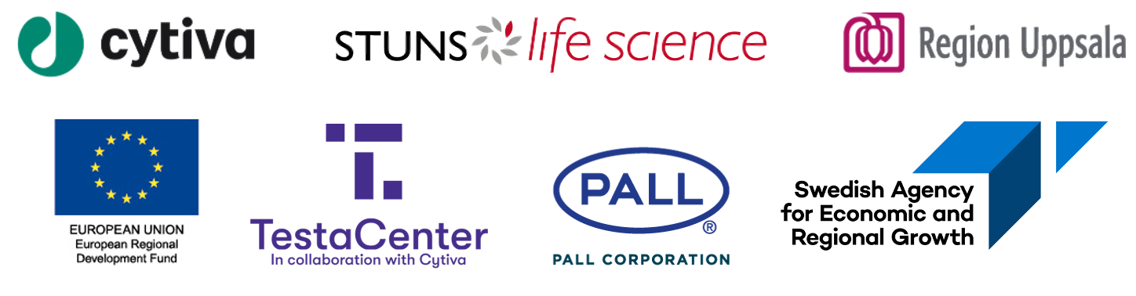

Version: 1.0
Project title: Click or tap here to enter text.
Today’s date: Click or tap to enter a date.

Confidentiality
Applications will be handled discretely, and only selected projects will be made public. Nevertheless, we recommend you to not include any confidential information in the application. After selection, all admitted applications will be deleted from our servers, and reviewers will be prompted to the best to delete files.
I understand and agree with the above information: Choose an item.

De minimis aid
The company is eligible for de minimis aid and is prepared to fill in a certificate if selected: Choose an item.

Company
Name: Click or tap here to enter text.
Website: Click or tap here to enter text.
Address: Click or tap here to enter text.
Country: Click or tap here to enter text.

Contact person
Name: Click or tap here to enter text.
Phone number: Click or tap here to enter text.
Email: Click or tap here to enter text.

The Testa Challenge team
Participant names: Click or tap here to enter text.

Innovation
Description (max 40 words)
Click or tap here to enter text.
Keywords
Click or tap here to enter text.
Technical readiness level (see Appendix 1) Choose an item.

Background (max 200 words)
Describe the current status of your project development including the research and/or rationale behind the idea. Describe activities and results which have led to the existing TRL, and any other relevant information. What data do you have at this stage? (Proof-of-concept etc).
Click or tap here to enter text.

Enhancing the bioprocessing workflow (max 200 words)
Describe the unmet need you are addressing and the potential effect of your solution/final product.
Click or tap here to enter text.

Intellectual property (max 100 words)
Have you filed a patent application? Has any professional freedom to operate (FTO) analysis and/or novelty search been carried out? If relevant, justify your decision not to protect your idea.
Click or tap here to enter text.

Note that if your project is selected you will need to define your background IP. To see an example, visit our website.

Briefly, describe the proposed project for Testa Challenge (max 200 words)
In short, describe the project you would like to run as part of the Testa Challenge. Do you know what equipment (instruments and basic methods) is needed for the proposed center project?
Click or tap here to enter text.

What interests you most about the challenge? (max 100 words)
What are you most anticipating to achieving for this challenge?
Click or tap here to enter text.

Market, competition, and business development (max 200 words)
Briefly, describe who is the customer/end-user of your product? What are your unique competitive advantages? Current and future plans; will you take the project to the market yourselves, or apply another business strategy?
Click or tap here to enter text.

I agree to security and privacy policy
Choose an item.

Appendix 1 –Technology Readiness Levels (TRLs)

TRL | General description of TRL | Example: Technology based solutions | Example: Software based solutions
1 | Basic principles and research data observed and reported | Scientific research findings are reviewed and assessed, and translation into applied research and new technologies begun. | Scientific research begins to be translated into applied R&D activities. Concepts evaluated that can be implemented in development of e/m-technology (software, sensors, devices, infrastructure or process).
2 | Technology concept and/or practical application formulated | Hypothesis, research ideas, protocols and experimental designs are developed. The potential ability of particular technologies, materials, and processes to address certain health problems identified. | Invention of potentially practical technology solutions addressing particular needs.
3 | Analytical and experimental Proof of Concept of critical function and /or characteristics | Active R&D initiated. Hypothesis testing, data collection, identification and evaluation of critical technologies and components and early proof of concept in laboratory models. | Active R&D initiated. Analytical studies to validate predictions of technology components of the technology that satisfy a need – forming the system application. System application tested in laboratory environment.
4 | Validation of the technology in the laboratory | R&D. Laboratory testing of critical components and processes. Proof of concept of device demonstrated in relevant laboratory models. | System components integrated and tested regarding preliminary efficiency and reliability. Software architecture and other system components development to address reliability, scalability, operability, security etc. Other system components development.
5 | Validation of technology in a relevant environment | Further development of device candidates and system solutions. Validation of system components and processes in relevant laboratory environment. Classification of device by appropriate regulatory body. | System component architecture established. System tested in relevant testing environment as expected in the operational environment. Verification, validation and accreditation when appropriate initiated.
6 | Demonstration of technology in relevant environment | System/device prototype demonstrated in an operational environment. | Representative model or prototype system demonstrated in relevant live or simulated environment. System component releases are “beta” versions and configuration controlled. Support structure in development and verification and validation and when needed accreditation for safety reasons in progress.
7 | Technology prototype demonstrated in an operational environment | Validation conducted using a fully integrated prototype version of the device in an operational environment. Data evaluated to support further development The final product design validated and final prototype and/or device intended for commercial use produced and tested. | System tested in an operational environment. Support structure in place and System component releases in distinct versions. Verification, validation and when appropriate accreditation completed.
8 | Technology system completed and qualified through test and demonstration | Development completed.  Relevant regulatory approvals achieved. | Development completed.  System demonstrated to work under real life conditions. Testing of design specifications. System component releases are production versions. Support structure in place to resolve technical issues.  Relevant regulatory approvals achieved.
9 | Technology system in its final form ready for full (commercial) deployment in relevant operating environment | Product launched. | Product launched.

